1. **What is a Prototype? What are Open source and closed source prototype platforms?**

A prototype is an initial version of a product created to test a concept or process. It serves to evaluate new designs, demonstrate functionality, and collect feedback before developing the final version. Essentially, it is the early sample or model from which future iterations are developed.

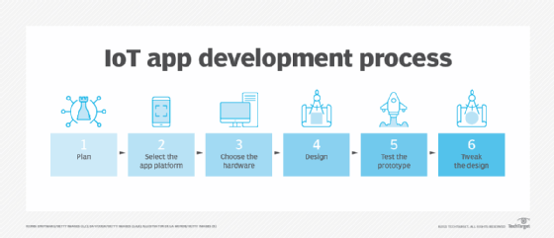

[Open source software](https://www.geeksforgeeks.org/open-source-freeware-and-shareware-softwares/) refers to computer software whose source is open means the general public can access and use it. The source code of open-source software is public and it encourages community contributions and collaborative development means users can modify and adapt the platform to suit their specific needs.

Some **examples of open-source software** are :

Firefox, MySQL, Arduino, Raspberry Pi, TeX, etc.

Closed source software refers to computer software whose source code is closed means the public is not given access to the source code means source code and design are owned by the company, and not available to the public and it often comes with professional support, documentation, and updates. It requires a license or subscription fee.

Some **examples of closed-source software** are :

Skype, Google earth, Adobe Flash, Virtual Box, Adobe Reader, Microsoft office, etc.

1. **What is Arduino?**

Arduino is an open-source electronics platform featuring easy-to-use hardware and software. It is designed for artists, designers, hobbyists, and anyone interested in creating interactive projects. Arduino boards can read inputs such as light on a sensor, a finger on a button, or a Twitter message, and convert them into outputs like activating a motor, turning on an LED, or publishing something online.

Applications:

1. Education: Widely used to teach electronics, programming, and robotics.

2. Prototyping: Ideal for creating prototypes for new inventions and concepts.

3. DIY Projects: Popular among hobbyists for home automation, wearable tech, and other personal projects.

**3.Write down Arduino Uno R3 Key Specifications:**

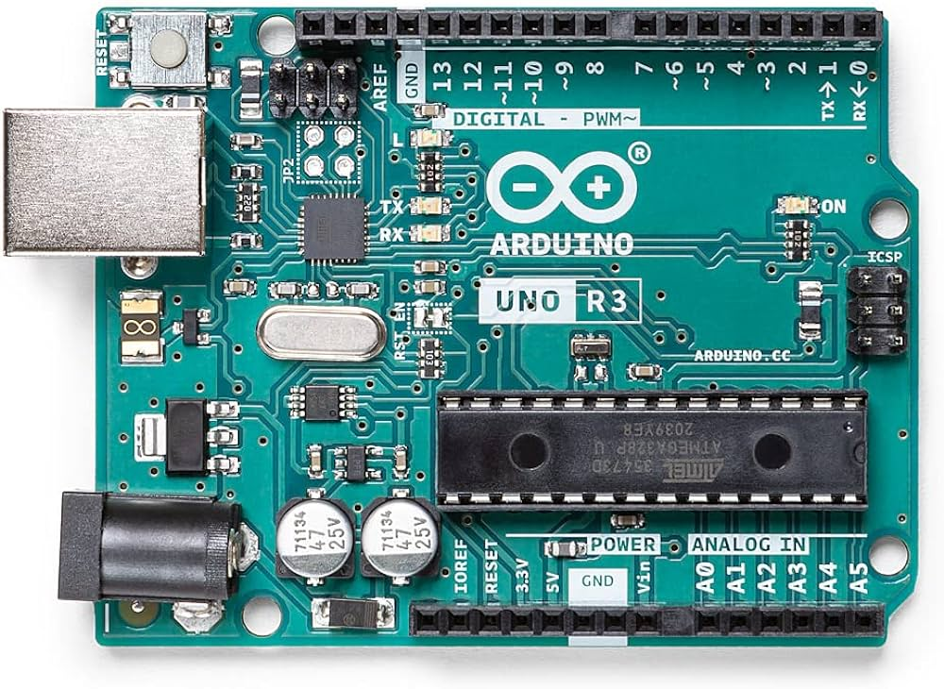

**Main Processor:**

* **Microcontroller:** ATmega328P

**Memory:**

* **SRAM:** 2 KB (ATmega328P)
* **Flash Memory:** 32 KB (ATmega328P) of which 0.5 KB is used by the bootloader
* **EEPROM:** 1 KB (ATmega328P)

**I/O Pins:**

* **Digital I/O Pins:** 14 (of which 6 provide PWM output)
* **Analog Input Pins:** 6
* **PWM Output Pins:** 6 (Pins: 3, 5, 6, 9, 10, 11)
* **UART:** 1 (Serial communication via pins 0 (RX) and 1 (TX))
* **I2C:** 1 (Inter-Integrated Circuit communication via A4 (SDA) and A5 (SCL))
* **SPI:** 1 (Serial Peripheral Interface communication via pins 10 (SS), 11 (MOSI), 12 (MISO), and 13 (SCK))
* **LED_BUILTIN:** 1 (Pin 13)